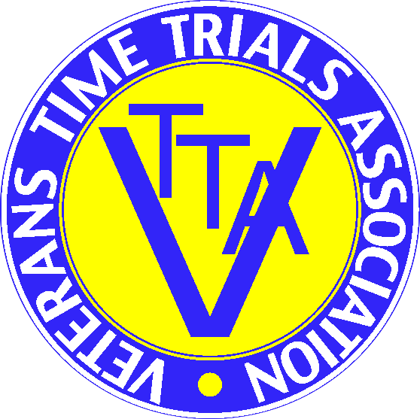 VTTA NORTH LANCS & LAKES OPEN 50
4th July 2021 RESULT SHEET
Including the NLTTA Championship 50
Promoted for and on behalf of Cycling Time Trials under their rules and regulations.
Event Sec. & Timekeeper: Richard Taylor 15 Tame Barn Close, Milnrow, Rochdale OL16 3XA
Assistant Timekeeper: Tracey Moore
PRIZEWINNERS
STANDARD
1st Mike Westmorland Border City Whs +33.54 £40
2nd Lee Foster Border City Whs +32.26 £30
3rd Derek McMillan SVTTA +31.52 £20
4th David Rundall Chorley CC +31.19 £15
Woman Debbie Moss Team Merlin +30.43 £30
2nd Sue Cheetham North Lancs RC +24.16 £20

Team Border City Whs Mike Westmorland +33.54, Lee Foster +32.26, Bill Maxwell +26.21 +92.41 £15 each

FASTEST
1st Ben Stead 3RT 1.43.58 £40
2nd Tommy Murray GS Metro 1.44.28 £30
3rd Jack Levick Rose Race Team 1.44.30 £20
4th Tom Thornely Buxton CC/Sett Valley 1.45.56 £15
Woman Debbie Moss Team Merlin 2.1.38 £30
2nd Joanna Cebrat Bury Clarion 2.3.50 £20
3rd Sue Cheetham North Lancs RC 2.12.21 £15
Non VTTA Vet David Powell Horwich CC 1.47.42 £15

NLTTA Champions (TBC)
Man David Powell Horwich CC 1.47.42 £20
Woman Debbie Moss Team Merlin 2.1.38 £20

